**Fake News Detection**

**A Minor Project Work**

Submitted in Sixth Semester of Bachelor of Technology (B.Tech)

**In**

**Computer Science & Engineering**

**(Session: 2023-24)**



|  |  |
| --- | --- |
| **Submitted By** | **Under the Guidance of** |
| Student Name: SEJAL SONI  Enroll No: 0205CS201108  Student Name: RAJNEESH RAJAK  Enroll No: 0205CS201091  Student Name: SHAILJA PATEL  Enroll No: 0205CS201109  Student Name: VISHVESH RATHORE  Enroll No: 0205CS201129 | 1. **Dr. Ruchi. K. Patel**   (CSE)   1. **Sweta Kriplani mam**   (Project Guide) |
|  |  |

**Department of Computer Science & Engineering**

**SHRI RAM INSTITUTE OF TECHNOLOGY, JABALPUR (M.P.)**

**RAJIV GANDHI PROUDYOGIKI VISHWAVIDYALAYA, BHOPAL (M.P.)**



**CERTIFICATE**

**This is to certify that**

Sejal Soni (Enroll No.: 0205CS201108)

Shailja Patel (Enroll No.: 0205CS201109)

Rajneesh Rajak (Enroll No.: 0205CS201091)

Vishvesh Rathore (Enroll No.: 0205CS201129)

Students of 6th Semester, Computer Science & Engineering. S.R.I.T., Jabalpur have submitted their Minor Project Synopsis entitled **“Fake news detection ”**  for the completion of 6th Semester examination under the requirement for the degree of Bachelor of Technology as per R.G.P.V., Bhopal.

|  |  |  |
| --- | --- | --- |
| **Sweta Kriplani mam**  **(Project Guide)**  **Computer Science & Engineering**  **SRIT, Jabalpur , M.P.** |  | **Dr. Ruchi. K. Patel**  **(CSE)**  **Computer Science & Engineering**  **SRIT, Jabalpur , M.P.** |



**CERTIFICATE**

**This is to certify that**

Sejal Soni (Enroll No.: 0205CS201108)

Shailja Patel (Enroll No.: 0205CS201109)

Rajneesh Rajak (Enroll No.: 0205CS201091)

Vishvesh Rathore (Enroll No.: 0205CS201129)

Students of 6th Semester, Computer Science & Engineering. S.R.I.T., Jabalpur have submitted their Minor Project Synopsis entitled **“Fake News Detecttion”**  for the completion of 6th Semester examination under the requirement for the degree of Bachelor of Technology as per R.G.P.V., Bhopal.

|  |  |  |
| --- | --- | --- |
| **( INTERNAL EXAMINER )** |  | **( EXTERNAL EXAMINER )** |



**ACKNOWLEDGEMENT**

I would like to express my deep sense of gratitude and sincere thanks to my guide Dr **. Sweta Kriplani ma**m & Dr . **Ruchi. K. Patel** Department of Computer Science & Engineering at SRIT, Jabalpur for his valuable and ever willing precious guidance , technical support and constant encouragement during the course of this project work. It was pleasure and unique experience for me to work under their guidance.

I am grateful to Dr. Ruchi. K. Patel, Head of Department of Computer Science & Engineering and other staff members of Computer Science and Engineering Department for providing the necessary facilities for the successful completion of this work.

Finally, my greatest thanks to my family for their patience and understanding.

Sejal Soni (Enroll No.: 0205CS201108)

Shailja Patel (Enroll No.: 0205CS201109)

Rajneesh Rajak (Enroll No.: 0205CS201091)

Vishvesh Rathore (Enroll No.: 0205CS201129)



**PREFACE**

This is a project report on **“ Fake News Detection ”** is related to Machine Learning .

Fake News on different platforms is spreading widely and is a matter of serious concern, as it causes social media wars and permanent breakage of the bonds established among peoples. I lot of research is already going on focused on the classification of fake news.

Fake News Detection is a Machine Learning Project in which we use Algorithm of Machine Learning to detect whether the news is Fake or Real .

**INDEX**

|  |  |  |
| --- | --- | --- |
| **SNo.** | **TOPICS** | **PAGE NO.** |
| 1 | INTRODUCTION |  |
| 2 | ANALYSIS   1. Objective 2. Requirement Gathering 3. Hardware Requirement 4. Software Requirement 5. Feasible Study 6. Cost Estimation |  |
| 3 | DESIGN   1. Data Flow Diagram 2. System Flow Diagram 3. User Interface Diagram |  |
| 4 | TECHNOLOGIES AND TOOLS USED |  |
| 5 | IMPLEMENTATION AND RESULT |  |
| 6 | CONCLUSION |  |
| 7 | REFERENCE |  |

1. **INTRODUCTION**

This is a project report on **“ Fake News Detection ”** is related to Machine Learning .

Fake News on different platforms is spreading widely and is a matter of serious concern, as it causes social media wars and permanent breakage of the bonds established among peoples. I lot of research is already going on focused on the classification of fake news.

Fake News Detection is a Project in which we use Algorithm of Machine Learning to detect whether the news is Fake or Real .

1. **ANALYSIS**
2. **Objective**

to create a simple Machine Learning Model to classify weather the news is real or fake .

1. **Requirement Gathering**

Requirements Gathering is a fundamental part of any software development project. These are things like “User wants to do X.

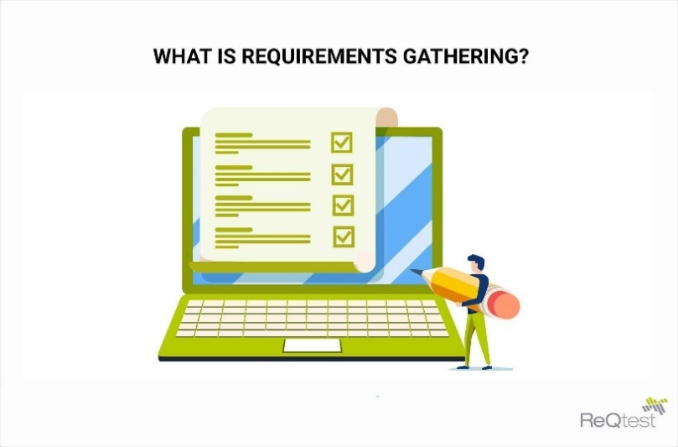

1. **Requirement**

Operating Systems: Windows 7 SP1 or later (64-bit), x86-64 based.

Disk Space: 1.64 GB (does not include disk space for IDE/tools).

Tools: PYTHON , Machine learning ,jupyter notebook .

Windows PowerShell 5.0 or newer (this is pre-installed with Windows 10)

* 1. Software Requirements
* Python Programming language
* Jupyter Notebook
* Machine Learning Algorithm

1. Logistic Regression
2. Decision Tree classifier
3. Passive aggressive classifier
4. **Feasibility Study**

Feasibility Study in Software Engineering is a study to evaluate feasibility of proposed project or system. Feasibility study is one of stage among important four stages of Software Project Management Process. As name suggests feasibility study is the feasibility analysis or it is a measure of the software product in terms of how much beneficial product development will be for the organization in a practical point of view. Feasibility study is carried out based on many purposes to analyse whether software product will be right in terms of development, implantation, contribution of project to the organization etc

**Types of Feasibility Study :**

The feasibility study mainly concentrates on below five mentioned areas. Among these Economic Feasibility Study is most important part of the feasibility analysis and Legal Feasibility Study is less considered feasibility analysis.

1. **TechnicalFeasibility –**   
   In Technical Feasibility current resources both hardware software along with required technology are analyzed/assessed to develop project. This technical feasibility study gives report whether there exists correct required resources and technologies which will be used for project development. Along with this, feasibility study also analyzes technical skills and capabilities of technical team, existing technology can be used or not, maintenance and up-gradation is easy or not for chosen technology etc.
2. **OperationalFeasibility**  
   In Operational Feasibility degree of providing service to requirements is analyzed along with how much easy product will be to operate and maintenance after deployment. Along with this other operational scopes are determining usability of product, Determining suggested solution by software development team is acceptable or not etc.
3. **EconomicFeasibility –**   
   In Economic Feasibility study cost and benefit of the project is analyzed. Means under this feasibility study a detail analysis is carried out what will be cost of the project for development which includes all required cost for final development like hardware and software resource required, design and development cost and operational cost and so on. After that it is analyzed whether project will be beneficial in terms of finance for organization or not.

1. **LegalFeasibility –**   
   In Legal Feasibility study project is analyzed in legality point of view. This includes analyzing barriers of legal implementation of project, data protection acts or social media laws, project certificate, license, copyright etc. Overall it can be said that Legal Feasibility Study is study to know if proposed project conform legal and ethical requirements.

1. **ScheduleFeasibility –**   
   In Schedule Feasibility Study mainly timelines/deadlines is analyzed for proposed project which includes how many times teams will take to complete final project which has a great impact on the organization as purpose of project may fail if it can’t be completed on time.

**Need of Feasibility Study :**

Feasibility study is so important stage of Software Project Management Process as after completion of feasibility study it gives a conclusion of whether to go ahead with proposed project as it is practically feasible or to stop proposed project here as it is not right/feasible to develop or to think/analyse about proposed project again.Along with this Feasibility study helps in identifying risk factors involved in developing and deploying system and planning for risk analysis also narrows the business alternatives and enhance success rate analyzing.

1. **Cost Estimation**

Software cost comprises a small percentage of overall computer based system cost. There are a number of factors, which are considered , that can affect the ultimate cost of the software such as –human, technical, hardware and software availability etc.

The main point that was considered during the cost estimation of project was its sizing. In spite of the complete software sizing , function point and approximate lines of code were also used to “size” each element of the Software and their costing.

The cost estimation done by me for Project also depend upon the baseline metrics collected from past projects and these were used in conjunction with estimation variables to develop cost and effort projections.

We have basically estimated this project mainly of two bases-

1. Effort Estimation – This refer to the total man hours required for the development of the project. It even includes the time required for doing documentation and user manual.
2. Hardware Required Estimation – This includes the cost of the PCs and the Hardware cost required for development of this project.
3. **DESIGN**
4. **Data Flow Diagram**

A data flow diagram show the logical flow of the system For a system it describes the input(source), output (destination), database (data stores) and procedures (data flows)all in a format that meets the user’s requirement . When analysis prepares the logical system design, they specify the user needs at a level of details that virtually determines the information flow into an out of the system and the required data resources. The logical design also specifies input forms and screen layouts.

The activities following logical design are the procedure followed in the physical design e.g. producing programs, software, file and a working system. Design specifications instruct the user about what the system should do.

A Data Flow Diagram (DFD) is a traditional visual representation of theinformation flows within a system. A neat and clear DFD can depict the right amount of the system requirement graphically. It can be manual, automated, or a combination of both.

[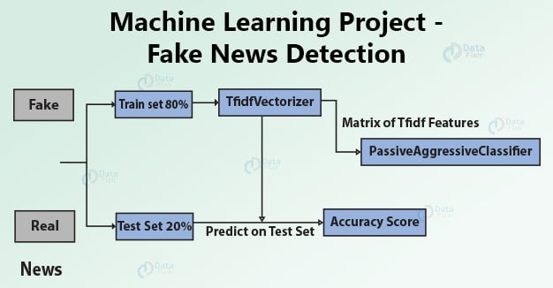](https://data-flair.training/blogs/wp-content/uploads/sites/2/2020/01/fake-news-detection.jpg)

Fig : Data Flow Diagram

1. **TECHNOLOGIES AND TOOLS USED**

* Python Programming Language

Python is an interpreted, object-oriented, high-level programming language with dynamic semantics. Its high-level built in data structures, combined with dynamic typing and dynamic binding, make it very attractive for Rapid Application Development, as well as for use as a scripting or glue language to connect existing components together. Python's simple, easy to learn syntax emphasizes readability and therefore reduces the cost of program maintenance. Python supports modules and packages, which encourages program modularity and code reuse. The Python interpreter and the extensive standard library are available in source or binary form without charge for all major platforms, and can be freely distributed.

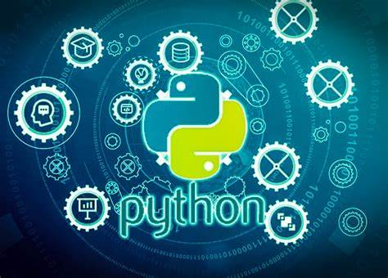

ii) JUPYTER NOOTBOOK



Jupyter Notebook is an open-source web application that allows you to create and share documents that contain live code, equations, visualizations, and narrative text. Uses include data cleaning and transformation, numerical simulation, statistical modeling, data visualization, machine learning, and much more.

1. **CONCLUSION**

This was the first considerably large and important project undertaken by us in B.Tech course. It was an experience that changed the way we received project development. The coding could not be started before the whole system was completely finalized. Even then there were so many changes required and the coding needed to be changed. On the whole it was a wonderful experience developing this project and we would have considered our education incomplete without undertaking such a project which allowed us to apply all that we learnt.

1. **REFERENCE**
2. Various open sources materials from internet
3. Training notes.
4. Discussion among the group and with guide
5. Some requirements are gathered through various books .

Git hub Link - https://github.com/vishveshrathore20/Fake-news-detection